**Phase 2: Org Setup & Configuration**

1. **Salesforce Edition**

* 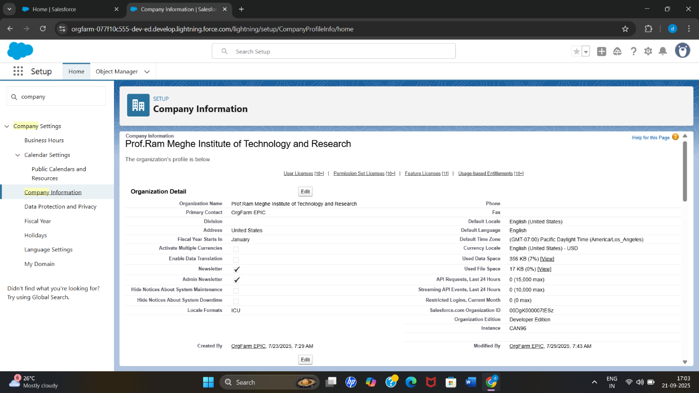The Developer Org used for implementation

1. **Company Profile Setup**

* The Company Profile in Salesforce was configured to set up the basics organizational details for the Project. This ensures the platform functions correctly with accurate date, time and currency formats.
* **Settings Configured:**
* **Company Name:** Prof. Ram Meghe Institute of Technology and Research
* **Currency Locale:** English (India) – INR
* **Default Time Zone:** (GMT+05:30) India Standard Time (Asia/Kolkata)

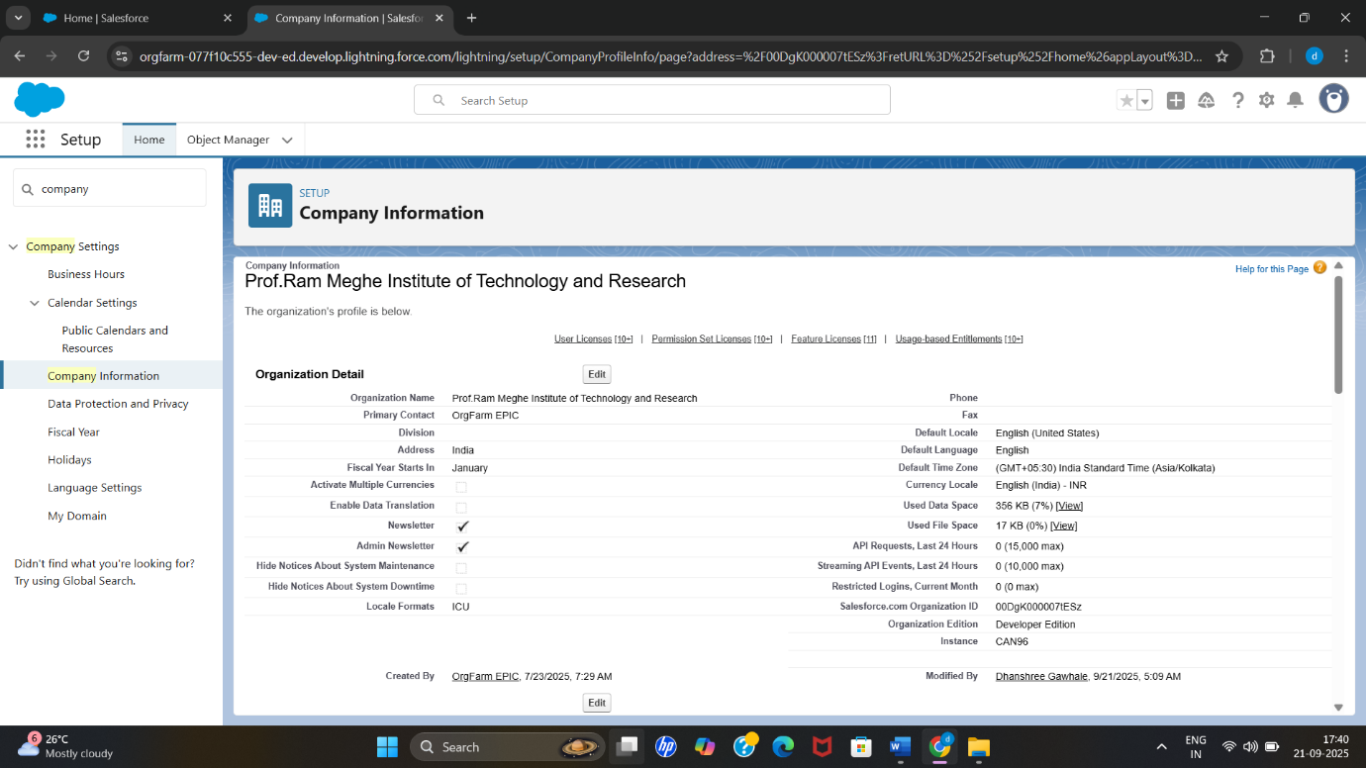

1. **Business Hours & Holidays**

* Business Hours setup for Movie Booking Platform no holidays configured as theaters operate Everyday.
* **Settings Configured:**
* From Monday - Sunday set the Business Hours time is 9:00 AM to 11:00 PM

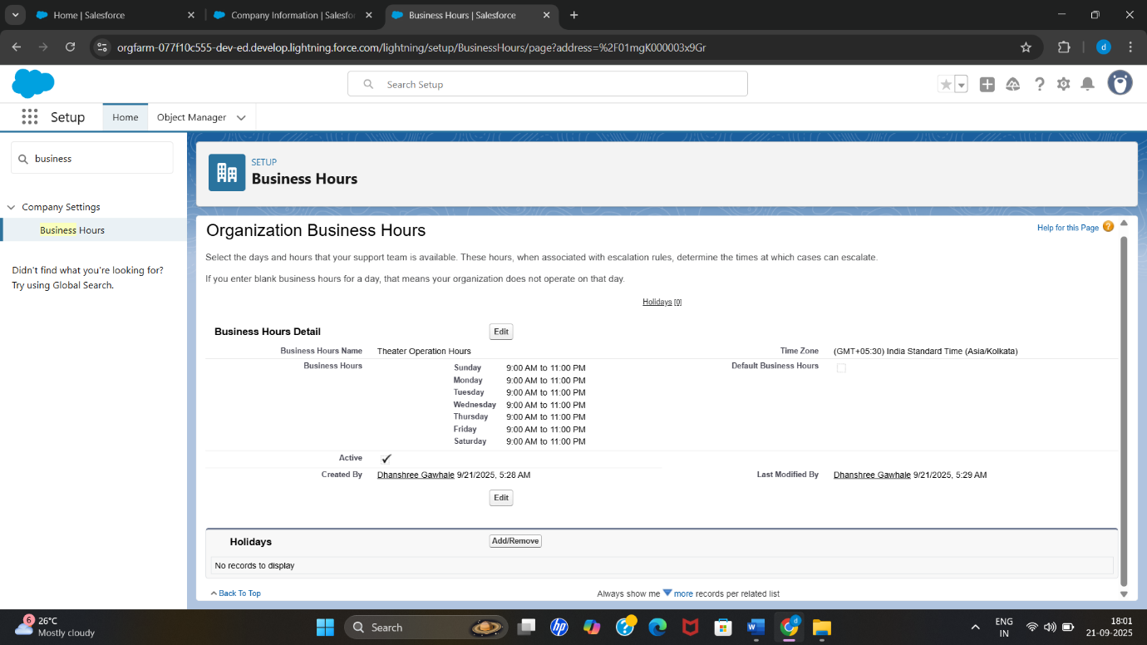

1. **User Setup & Licenses**

* **Admin:**
* Top level user with full access to all objects and records.
* Manages user, roles, profiles, and system settings.
* Generates reports and oversees theatre operations.
* 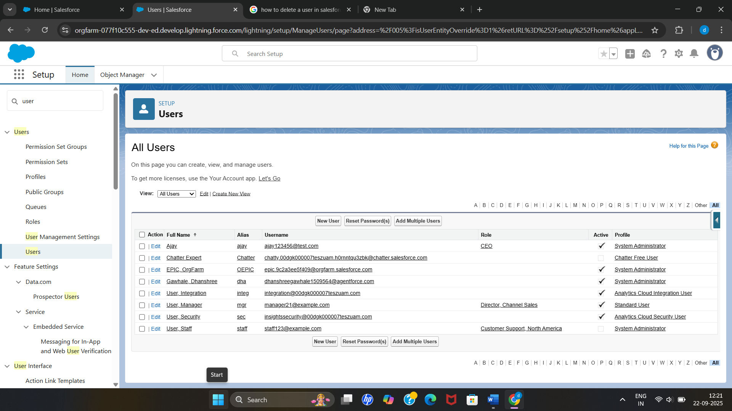Role: CEO | Profile: System Administrator | License: Salesforce
* **User Manager:**
* Middle level user manages shows, schedules, bookings and seat availability for their theater.
* Approve bookings and generate theatre-level reports.
* Role: Director Channel Sales | Profile: Standard User | License: Salesforce



* **User Staff:**
* Currently I deactivate these user when need I will activate it.
* Handles bookings and manages seats for shows reports to theatre Manager
* Role: Customer Support North America| Profile: System Administrator | License: Salesforce



1. **Profiles**

* Customer Profile (cloned from Standard User): Allows users to book tickets and view shows; read-only access to Movies and Shows.

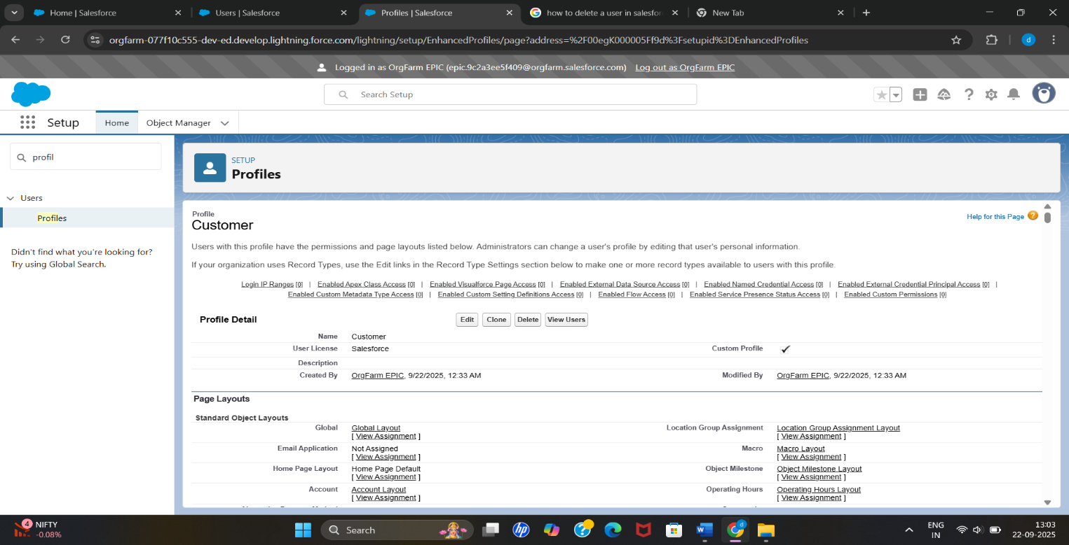

* 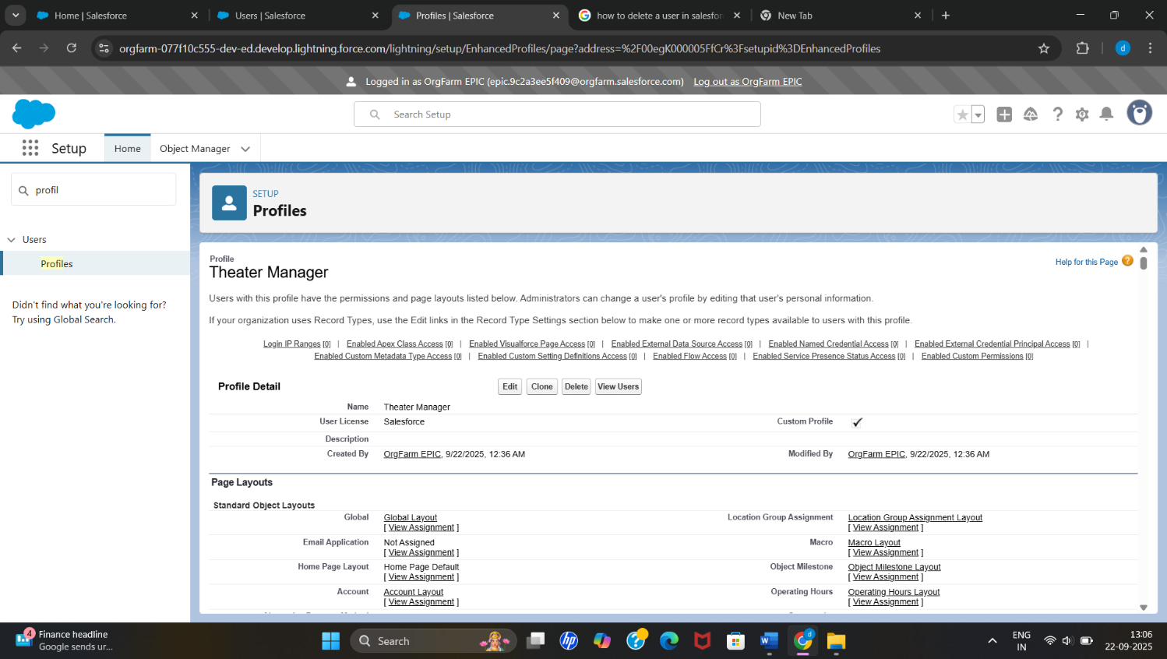**Theater Manager Profile (cloned from Standard User):** Manages shows, bookings, seats, and generates theater reports.
* **User** **Staff Profile (cloned from Standard User):** Handles customer bookings and seat assignments with limited access to Shows.

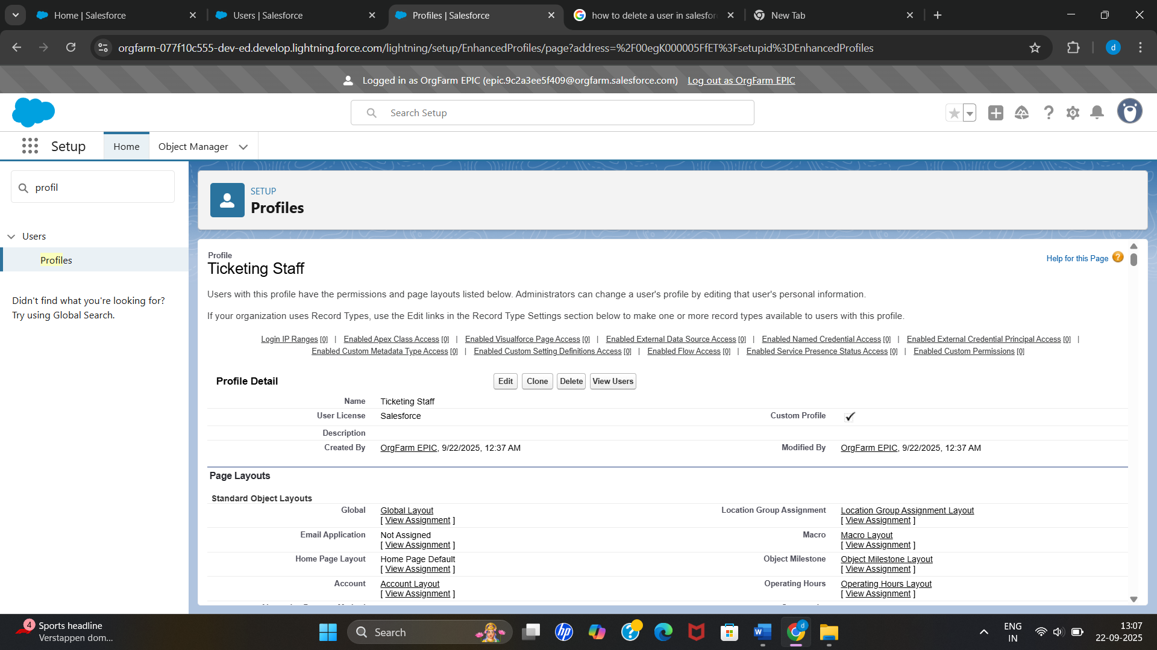

1. **Roles Hierarchy**

* 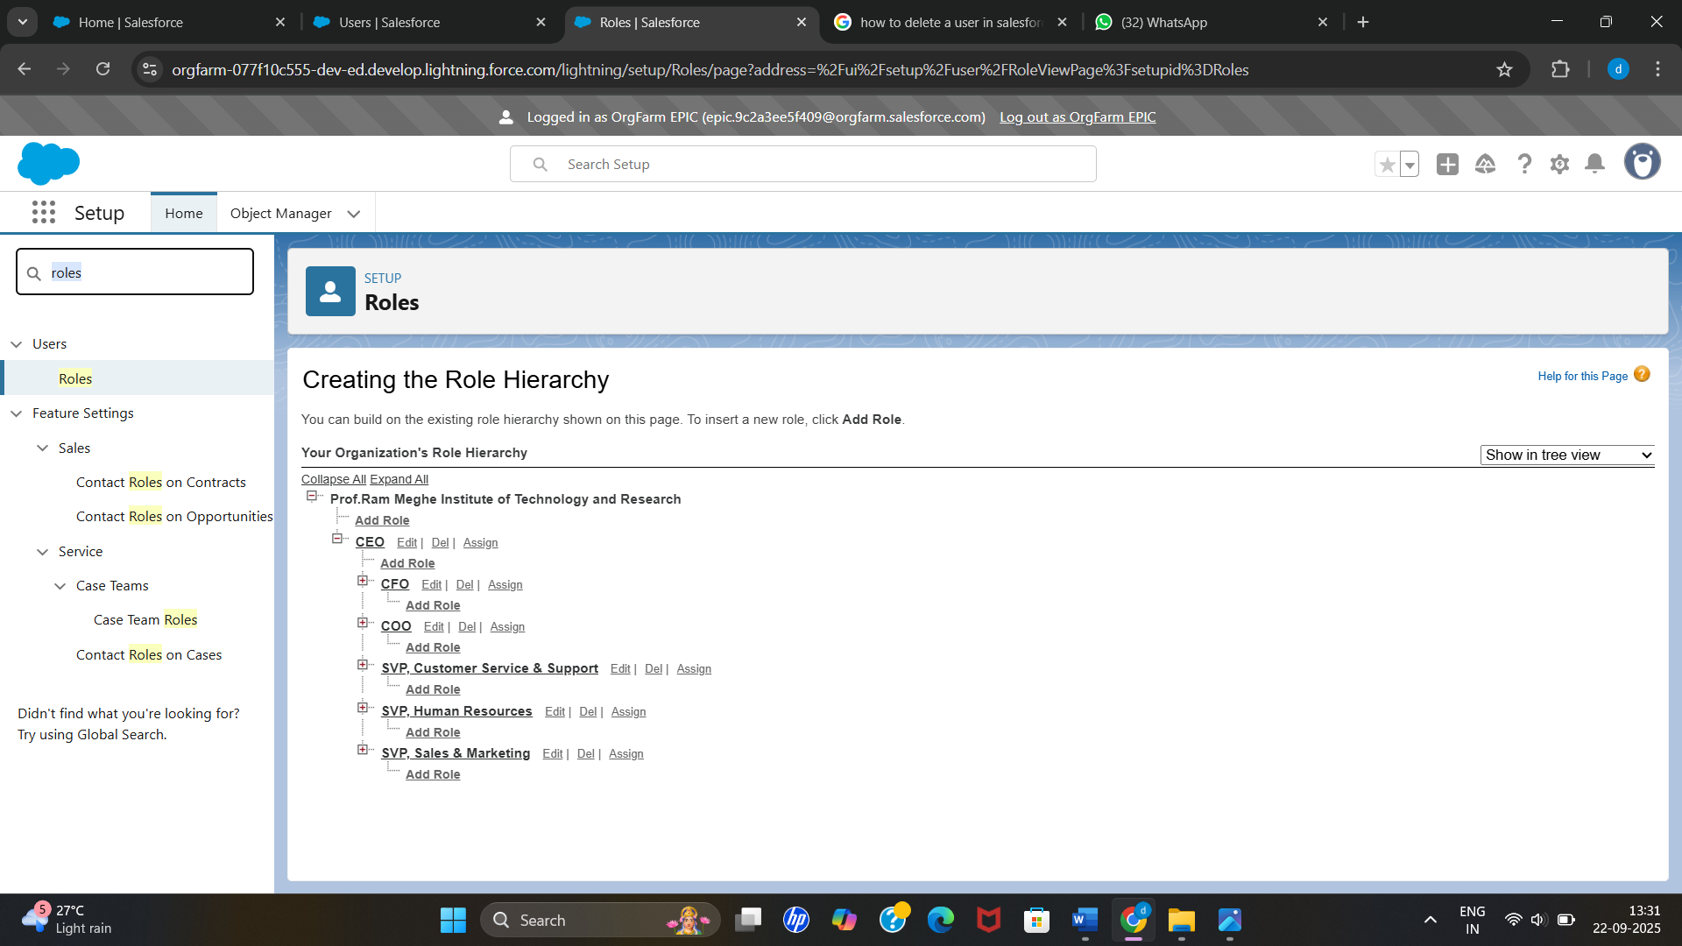Role Hierarchy: Ticketing Staff → Theater Manager → Admin for controlled access.

1. **Permission Sets**

* **Admin:** Full access via System Administrator profile; no permission set needed.
* **Theater Manager:** Permission Set allows managing bookings, seats, refunds, and reports.
* **User Staff:** Permission Set allows managing their own bookings and seat assignments.

1. **OWD**

* Set Booking and Customer to Private to protect customer and booking data.
* For Both the Objects Default Internal Access → Private
* Default External Access → Private

